**Weather historical datasets verification portal**

The purpose of this portal is to enable users to conduct personalized analyses to assess the precision of historical weather datasets accessible on the CE Hub for a specific variable and country/region/point. To evaluate the accuracy of each dataset, statistical metrics are utilized to compare its data against weather station data.

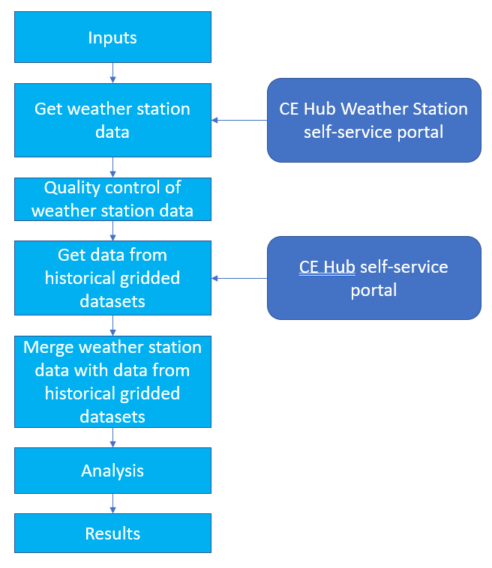

Figure : High-level workflow of the code

The following sections refer to the Jupyter Notebook: Automated_framework_historical.ipynb

**Inputs**

**Basic Inputs**

* Variable array (for example ['E_AIR_TEMPERATURE','E_RELATIVE_HUMIDITY', 'E_RAINFALL','E_DEWPOINT','E_WIND_SPEED']

*In the code the variable name is the same as for CE Hub weather station self-service portal*

* + *Checklist menu with variables*
  + *Allow multiple selection*
  + *Display the variable name as: Air temperature, Relative humidity, etc…*
* Aggregation array

For each variable above we should specify the aggregation (daily_mean, daily_max, daily_min, daily_sum)

* *Dropdown menu for each variable*
* *Just one selection*
* *For precipitation only dail_sum*
* Time aggregation: daily, weekly or monthly
  + *Daily as default*
* Possibility to run the analysis for one or multiple countries, regions or points
  + Country name (as in CE Hub WS self-service portal)
  + Region name (as in CE Hub WS self-service portal)
  + Point: latitude and longitude and radius. The code look for the WS within this radius
* Start and end date with this format '2021-01-01T00:00:00'

**Historical Gridded Datasets**

* Array of CE Hub gridded datasets

*We should display the table “Datasets_info.xlsx” and allow a checklist selection or the row of the table*

**Advanced Section**

**🡪** Possibility to skip it and get all the WS for the region/country/point from CE Hub WS portal

🡪 Otherwise get the WS data from CE Hub self-service portal and tune the WS-related parameters to get the number of WS they wish (minimum number of observations and minimum completeness)

🡪 Possibility to enter the list of station ID (stations available on the CE Hub WS portal)

🡪 Possibility to enter the coordinates of their stations and the weather observations

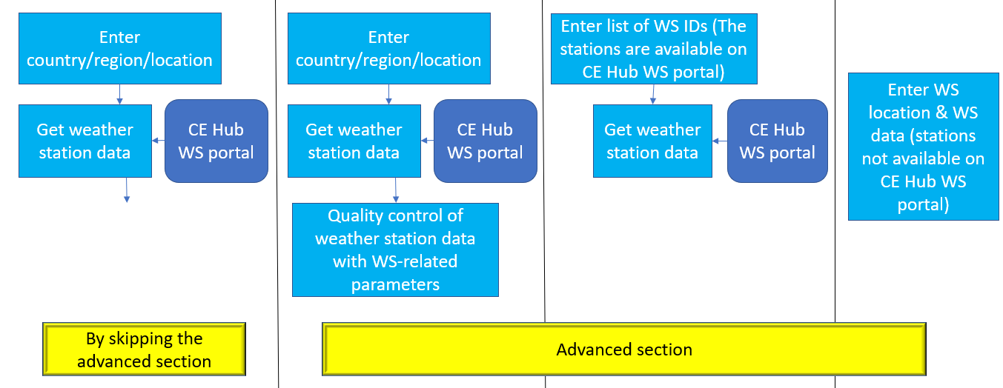

Inputs for this section:

* Weather stations-related parameters
* Suppliers: *default [“Davis”,”Arable”,”Pessl”,”Sencrop”]. Checklist menu for all the possible suplliers*

*The user should have the flexibility to play with the inputs to obtain the desired WS*

*Allow the user to see the WS on a map, the time series and WS by country for each variable (WS info 1, 2, 3).*

*The user can also input its data for the gridded dataset in this section*

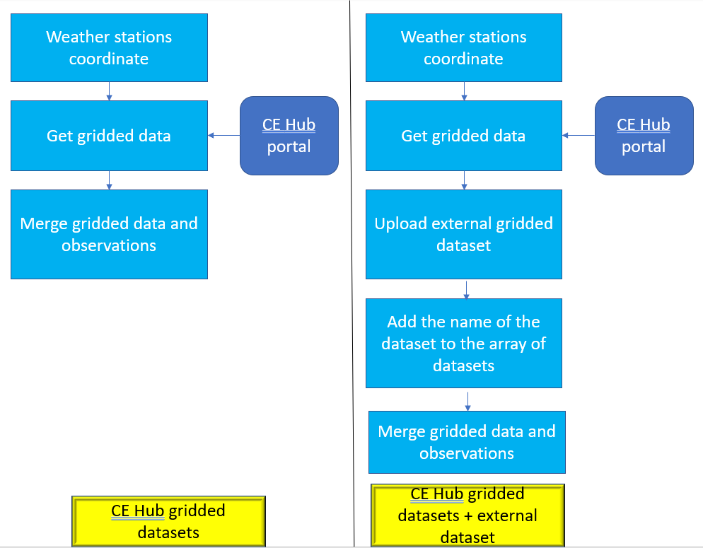

**Type of Output**

Array of statistical metrics: *Display the table “Metrics_info.xlsx” and allow a checklist selection of the row of the table*

*The previous inputs should be displayed as a multistep checkout as in the pictures below.*

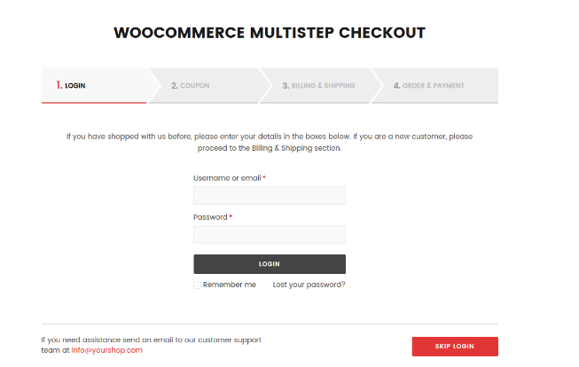

Additional inputs

* account_name=Syngenta email to create a bucket on CE Hub S3
* analysis_name to create a bucket on CE Hub S3

key_analysis=key + account_name + '/' + analysis_name

* AWS Keys and CE Hub’s keys from .env file

**Quick start**

**Scope:** Create the bucket for the analysis on CE Hub S3 and merge the variable and aggregation to simplify the code later

**Identification of WS based on the selection location/country/region**

**Scope:** Identify the station ID of the CE Hub’s weather station within the country/countries, region/regions or nearby the location (function not developed for the point).

This section is skipped if the user enters in the advance section the stationID of CE Hub’s WS or coordinates of external weather stations.

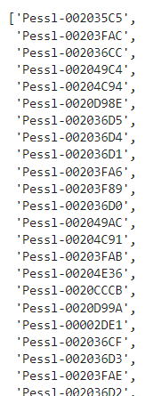

Figure : List of WS IDs

**Observations Data**

**Scope:** Download by means of API WS data from CE Hub WS portal.

This section is skipped if the user enters in the advance section the coordinates of external weather stations and their timeseries.

**Quality Control**

**Scope:** Quality control of CE Hub WS.

Checks:

### Above or equal minimum numbers of observations (input from the user)

### Completeness above or equal min_completeness (input from the user)

This section is skipped if the user enters in the advance section the stationID of CE Hub’s WS or coordinates of external weather stations.

**Visualization of the retained WS**

**Scope:** Display the **retained weather stations** for each variable

* on the **map** (WS info 1)
* *Possibility to unselect from the map the WS*
* *Possibility to see the time series of a WS by selecting it from the map*
* timeseries (WS info 2)
* number of WS by country (if multiple countries are prescribed as input or a region) (WS info 3)

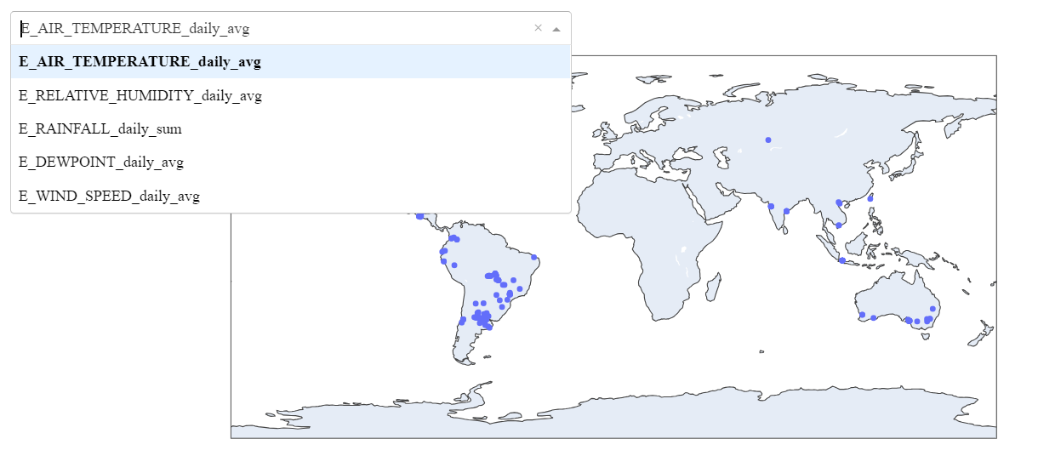

Figure : WS info 1

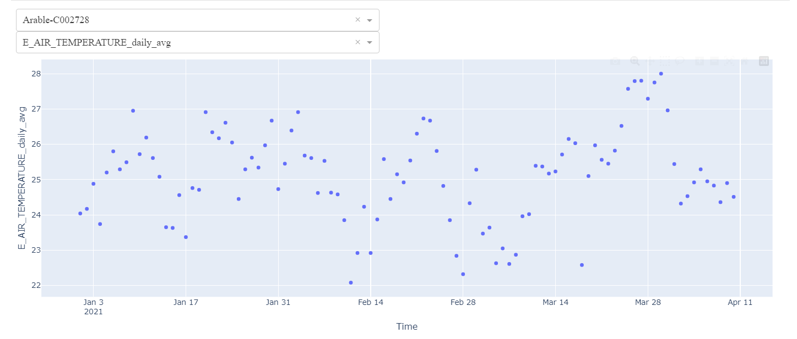

Figure : WS info 2

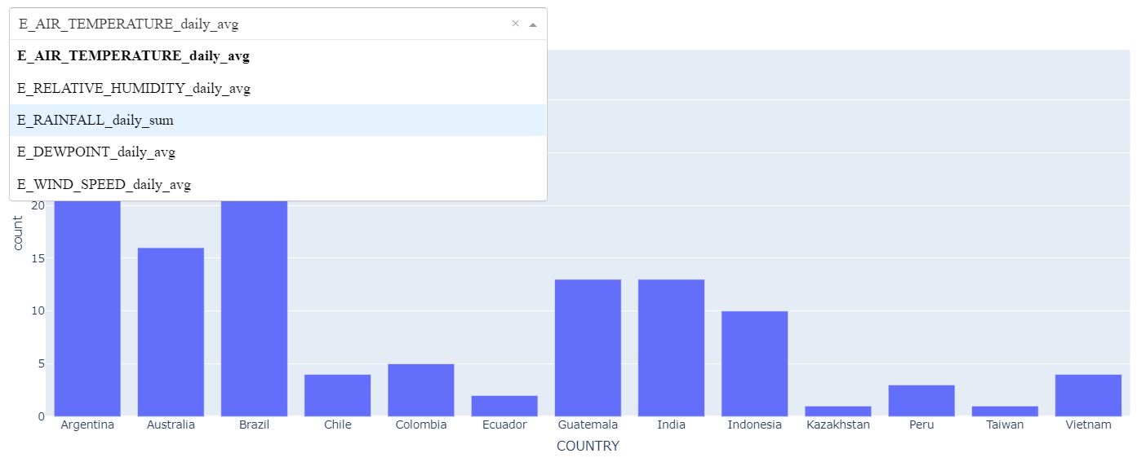

Figure : WS info 3

**Extraction of gridded datasets from CE Hub**

**Scope:** Based on latitude and longitude of the retained WS, the code gets gridded weather data from CE Hub self-service portal

It is also possible to enter a weather data from an external dataset using the advanced section. The dataset should have a daily resolution and this format: Time, StationID, Latitude, Longitude, variable+aggregation

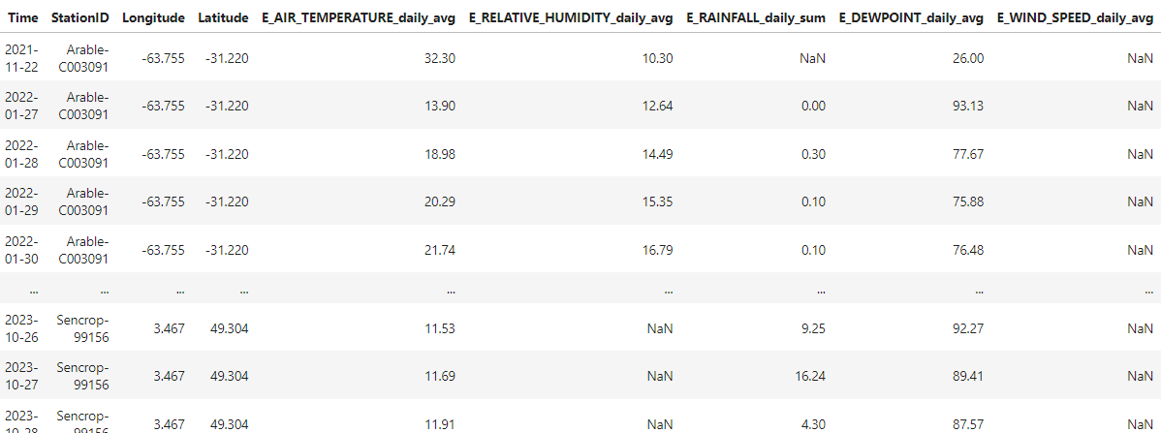

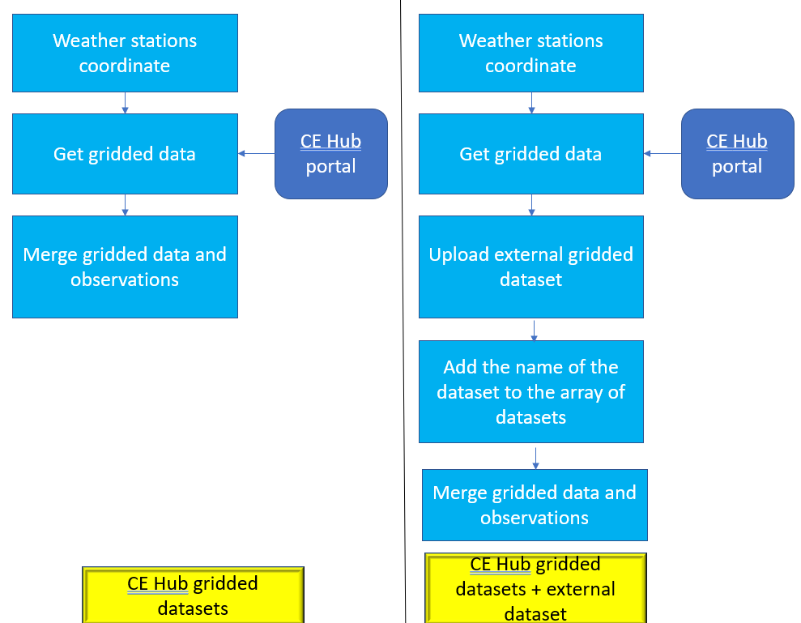

**Merge gridded datasets with WS observations**

**Scope:** Merge gridded weather data with WS observations based on StationID and Time.

**Time aggregation**

**Scope:** Aggregate data (gridded & observations), if selected by the user, weekly or monthly. Otherwise data remains with daily resolution.

**Creation of a unique dataframe**

**Scope:** For each variable merge observations and gridded data together

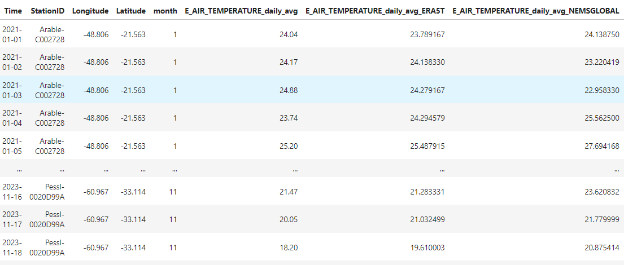

**Statistics**

**Scope:** Compute the statistics for each station and dataset

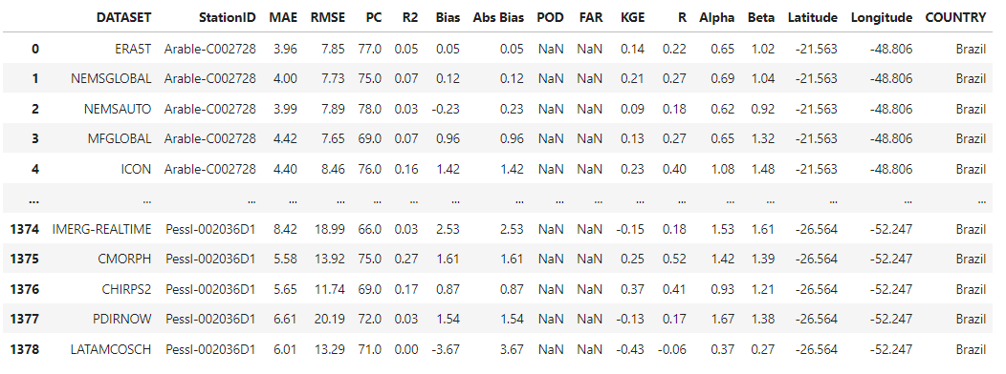

**Output**

**Scope:** Generate an interactive dashboard and a report(pdf) summarizing the results.

Dashboard

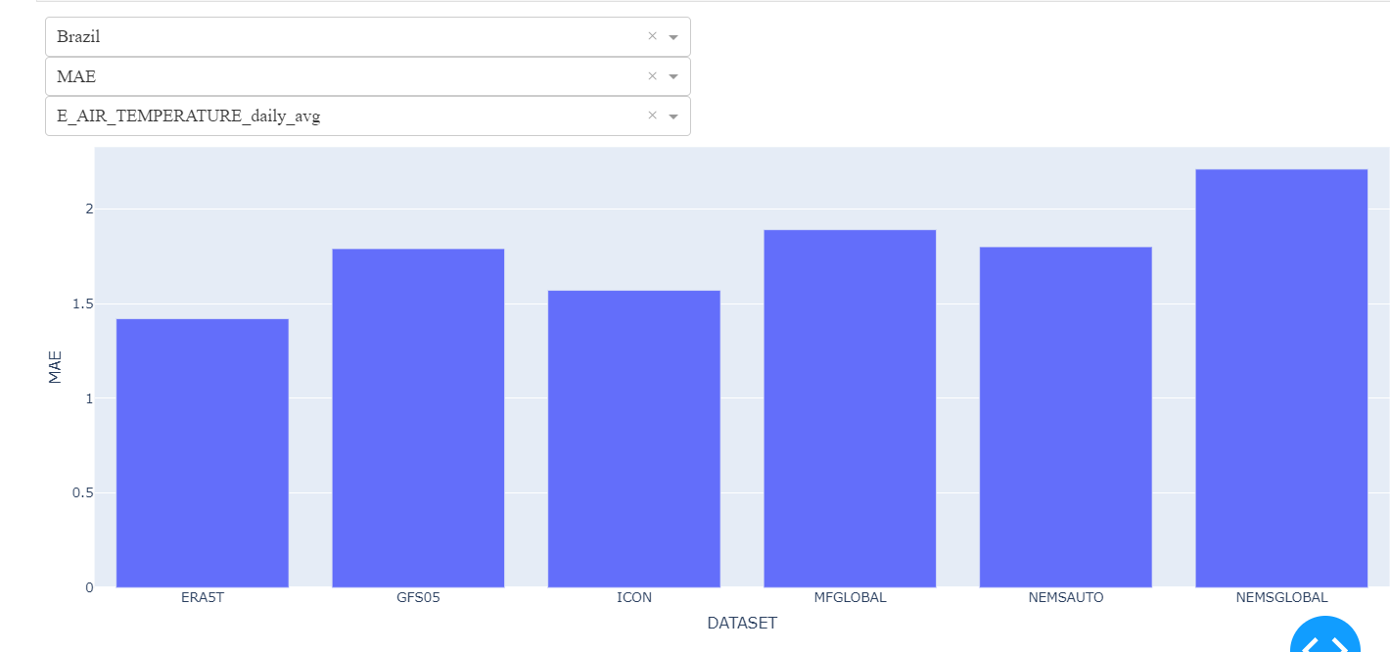

Figure : Output 1

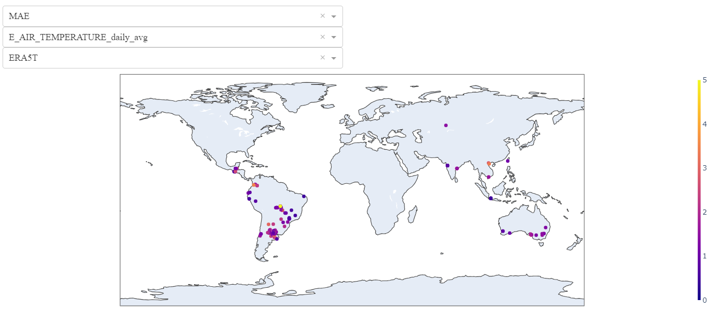

Figure : Output 2

*It would be better to display the plot for all the datasets one next to the other*.

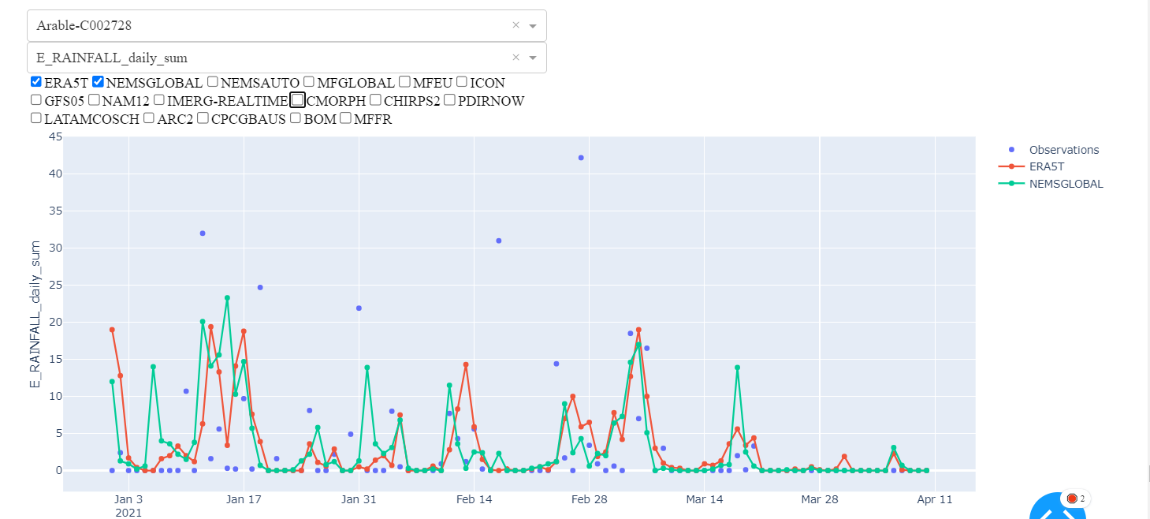

Figure : Output 3

*The plots can be downloaded as image or shared via email or get the raw data in excel (plot + inputs)*

Report

For each variable, we create a report containing:

* Inputs
* WS related info (WS info 1, WS info 3)
* Output (Output 1, Output 2)